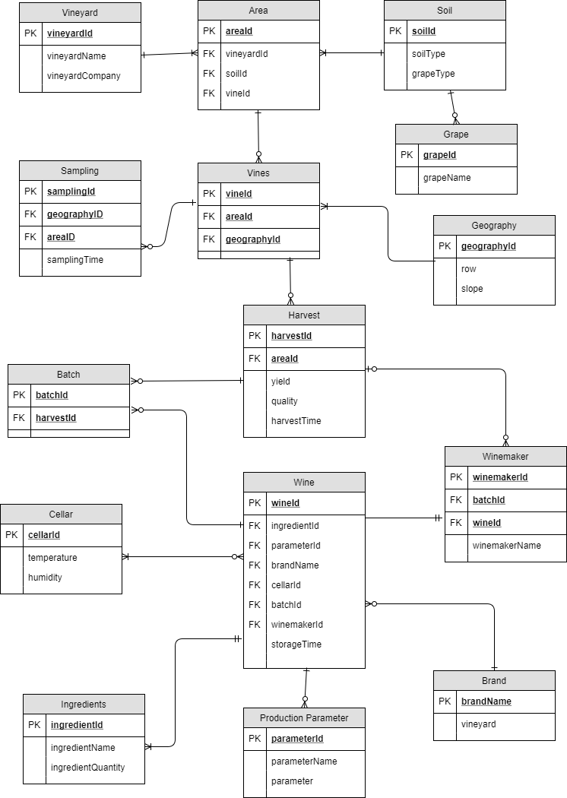

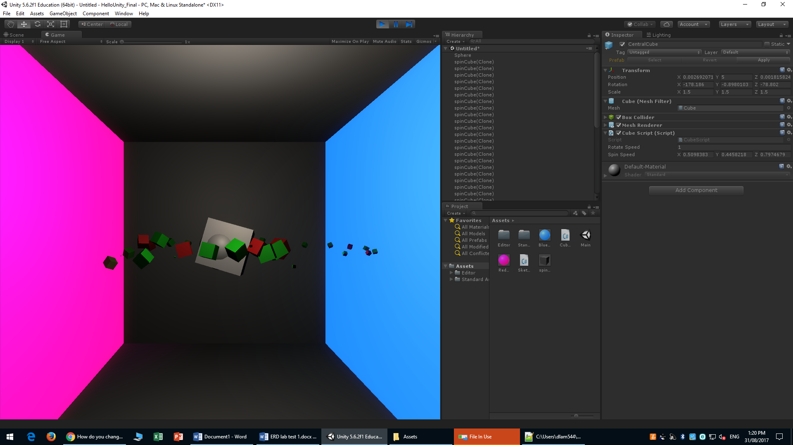

4. I did not know how to change every third object to a **Sphere** so I just changed them to a different colour to show.

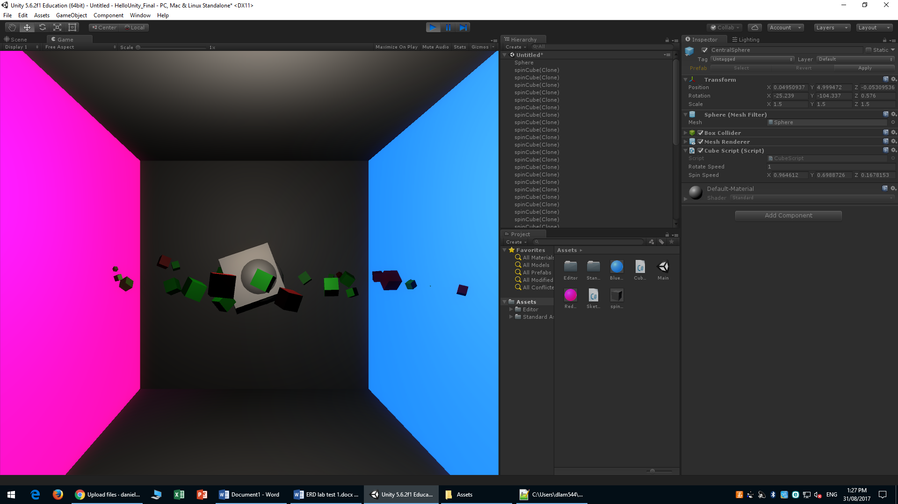

6. I made the Red cubes which were suppose to be Spheres appear at a different Z position.

<https://github.com/daniel-the-lamb/labtest1>

<https://github.com/daniel-the-lamb/labtest1>

<https://github.com/daniel-the-lamb/labtest1>